UML Class Diagram: Blood Donor Network

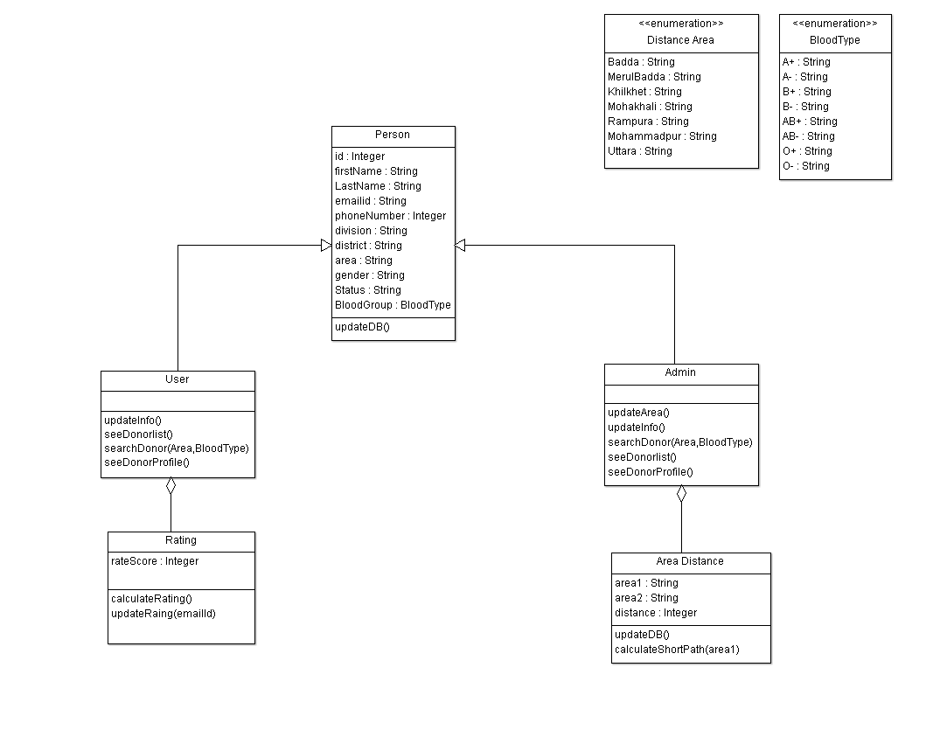

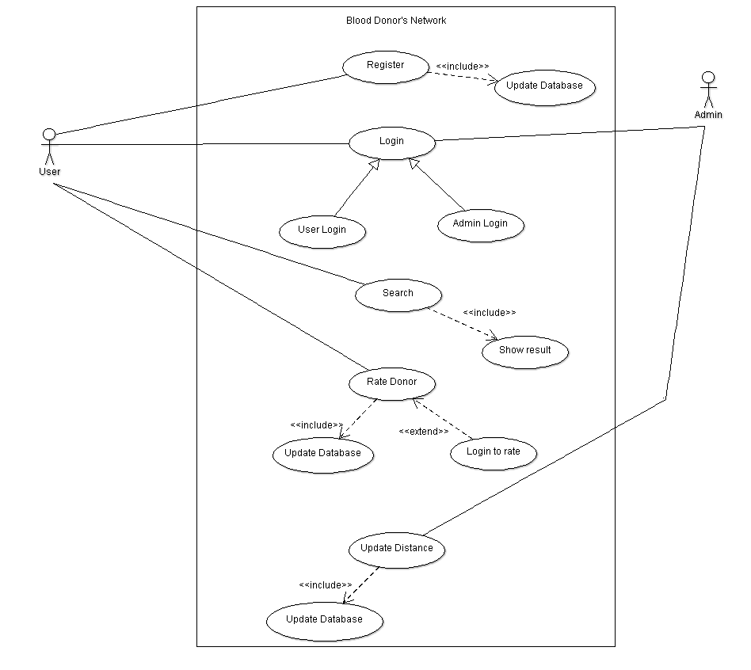UML Use Case Diagram: Blood Donor Network

UML Sequence Diagram: Blood Donor Network

